1. SharePoint Profile and User List Update PowerShell Script Components:

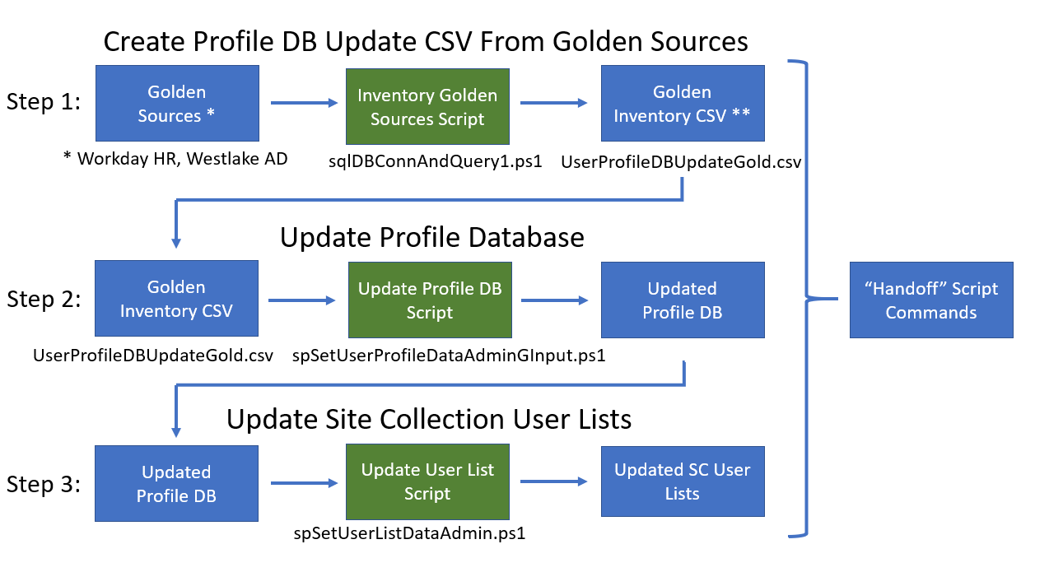

* 1. Atlas User Databases
     1. ATLAS UAT
     2. ATLAS PRD
  2. SharePoint Profile Database
  3. SharePoint User List
  4. PowerShell Scripts
     1. PowerShell Scripts
     2. CSV Input Files
     3. CSV Output Files
     4. Directory Structure
  5. Task Scheduler

1. Atlas User Database
   1. ATLAS UAT - Dbo.AD_WLK_Users
   2. ATLAS PRD - Dbo.AD_WLK_Users

1. SharePoint Profile Database – Default database in SharePoint Farm
2. SharePoint User List – Default SharePoint User Lists in the SharePoint Site Collections
3. PowerShell Scripts
   1. PowerShell Scripts:
      1. sqlDBConnAndQuery1.ps1
         * Notes: Script must run in an account that has DBO level access to the database.
         * Input File: N/A
         * Output File: AD_WLK_Users[dd-mm-yyyy-hh.mm.ms].csv
         * Error Log: N/A
         * Script Components:
           + Set Output File Variables
           + Set SQL Server and DB Variables
           + Set Connection Variables
           + Set SQL CMD Variables
           + Set SQL Adapter Variables
           + Set DataSet Variables - Fill Data Set - Export to CSV
           + Close the Connection
           + Start spSetUserProfileDataAdminGInput.ps1
      2. spSetUserProfileDataAdminGInput.ps1
         * Notes: Script must run in an account that has Farm Administrator level access to the SharePoint Farm.
         * Input File: \Scripts\CSVInput\UserProfileDBUpdateGold.csv
         * Output File: \Scripts\CSVOutput\UserProfileUpdateReport[dd-mm-yyyy-hh.mm.ms].csv
         * Error Log: \Scripts\ErrorLog\ErrorLog[dd-mm-yyyy-hh.ss.ms].csv
         * Script Components:
           + Set Site URL Variable
           + Process spoProfileUpdate File
           + Date Time Group Variable
           + Create an Error Log
           + Create Profile Report Variables
           + Process CSV Input File

Create Profile Object

Set Variable Values Equal to Table Values

Get User Profile Objects

Update Profile Add to Array

Commit Changes

Export User Profile data to CSV

Start spSetUserListDataAdmin3.ps1

* + 1. spSetUserListDataAdmin3.ps1
       - Notes: Script must run in an account that has Farm Administrator level access to the SharePoint Farm.
       - Input File: N/A
       - Output File: \Scripts\CSVOutput\UserListUpdateReport[dd-mm-yyyy-hh.mm.ms].csv
       - Error Log: N/A
       - Script Components:
         * Set Date Time Group Variable
         * Create Profile Report Variables
         * Define Property Map Array
         * Get SP Farm Context
         * Get Profile Manager Object
         * Process Thru Each SP Site User List in the SP Sites

Process Thru Each User in the SP Site User List

Process Thru the User Property Map for Each User

Write Results to Console and Output File

Write Error Message to Console

* + 1. spGetUserProfileDataAdmin2.ps1
       - Notes: Script must run in an account that has Farm Administrator level access to the SharePoint Farm.
       - Input File: N/A
       - Output File: c:\scripts\CSVOutput\UserProfileReport[dd-mm-yyyy-hh.mm.ms].csv
       - Error Log: N/A
       - Script Components:
         * Set Configuration Variables
         * Get Site Objects
         * Get All User Profiles
         * Create Array to Hold Profiles
         * Iterate Through Each Profile

Retrieve User Profile Properties

Add User Profile to Array

* + - * + Export User Profile Data to CSV
  1. CSV Input Files – UserProfileDBUpdateGold.csv, the input file for the spSetUserProfileDataGInput.ps1 PowerShell script.
  2. CSV Output Files:
     1. UserProfileUpdateReport[dd-mm-yyyy-hh.mm.ms].csv, the output file for the “spSetUserProfileDataGInput.ps1” PowerShell script.
     2. UserListUpdateReport[dd-mm-yyyy-hh.mm.ms].csv, the output file for the “spSetUserListDataAdmin3.ps1” PowerShell script.
     3. UserProfileReport[dd-mm-yyyy-hh.mm.ms].csv, the output file for the “spGetUserProfileDataAdmin2.ps1” PowerShell script.
     4. UserProfileDBUpdate.csv, the output file for the “sqlDBConnAndQuery1.ps1” PowerShell script.
  3. Directory Structure:

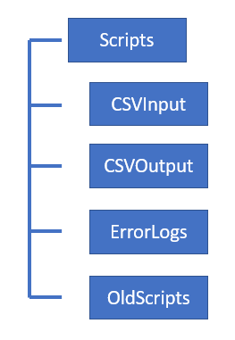

* + 1. Purpose – The Directory Structure of the solution provides a place for all artifacts that is logical and separated.
    2. Scripts – This is the top parent folder of the directory structure, this is where the main PowerShell solution files are stored. Files Stored here include:
       - sqlDBConnAndQuery1.ps1
       - spSetUserProfileDataAdminGInput.ps1
       - spSetUserListDataAdmin3.ps1
       - spGetUserProfileDataAdmin2.ps1
    3. CSVInput – This folder contains the “UserProfileDBUpdateGold.csv” file, the input file for the spSetUserProfileDataGInput.ps1 PowerShell script.
    4. CSVOutput:
       - UserProfileUpdateReport[dd-mm-yyyy-hh.mm.ms].csv
       - UserListUpdateReport[dd-mm-yyyy-hh.mm.ms].csv
       - UserProfileReport[dd-mm-yyyy-hh.mm.ms].csv
       - UserProfileDBUpdate.csv
    5. ErrorLogs: spSetUserProfileDataGInput-ErrorLog[dd-mm-yyyy-hh-mm-ms].csv
    6. OldScripts: This folder contains the older versions of scripts.

1. Task Scheduler
   1. Purpose: To automatically run the sqlDBConnAndQuery1.ps1 script once a day.
   2. Location: Should be configured to run from the same server the solution runs from.
   3. Settings:
      1. General:

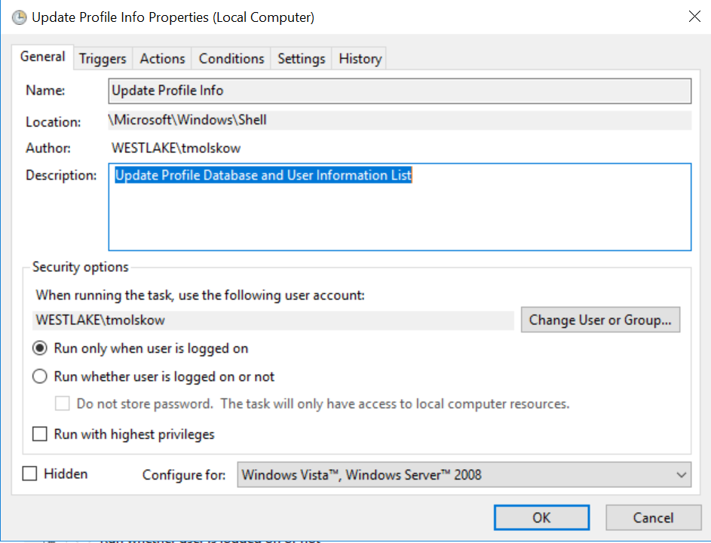

* + 1. Triggers (Schedule):

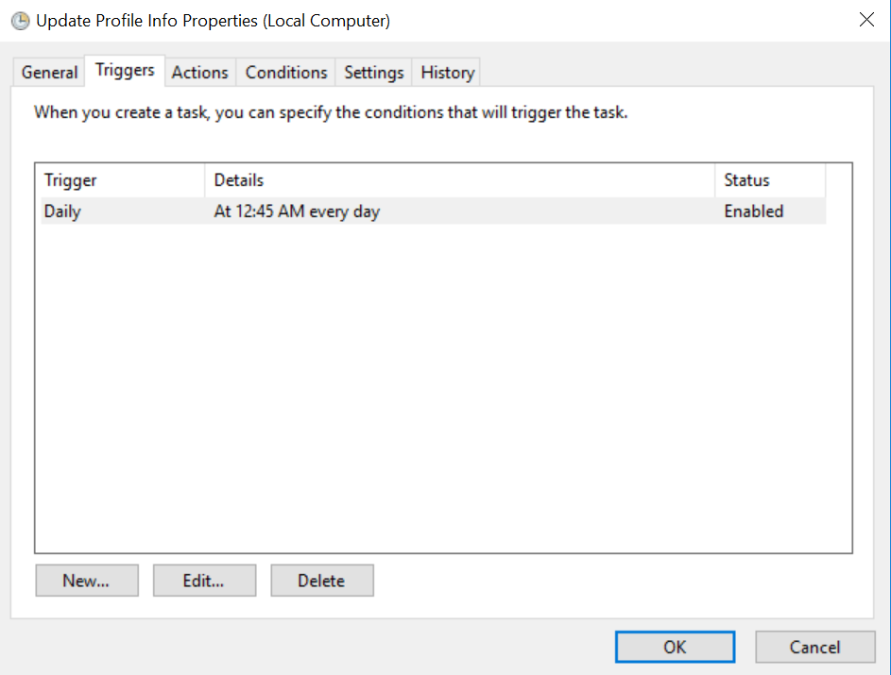

* + 1. Actions:

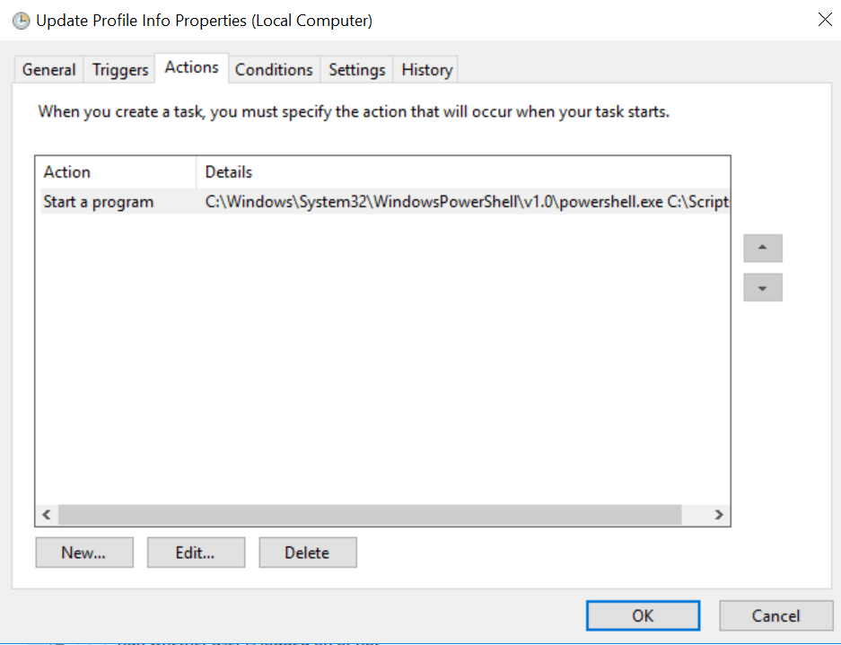

* + 1. Conditions:

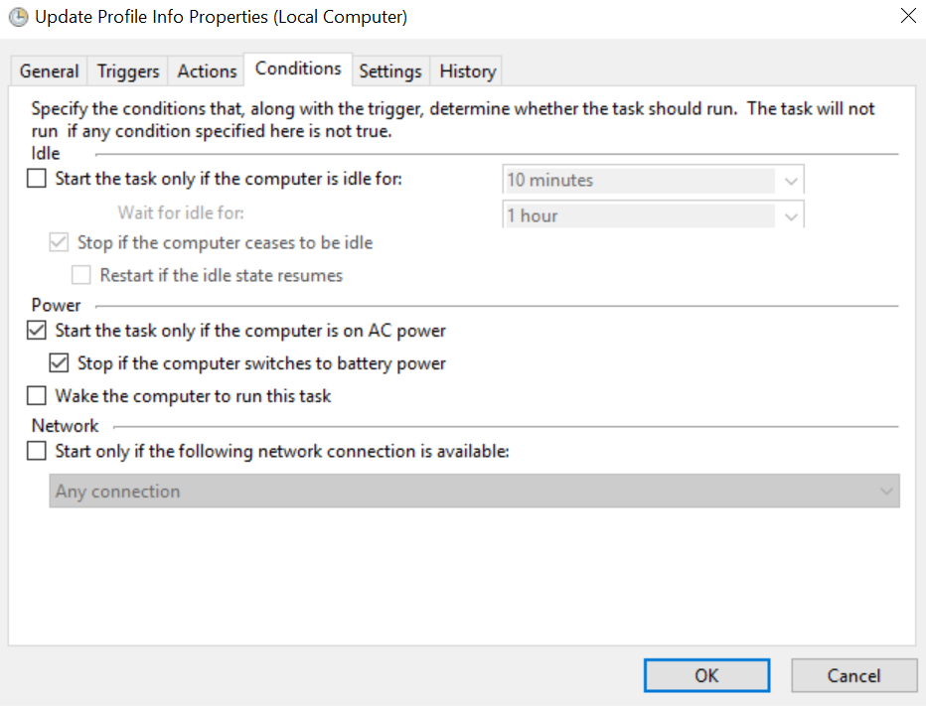

* + 1. Settings:

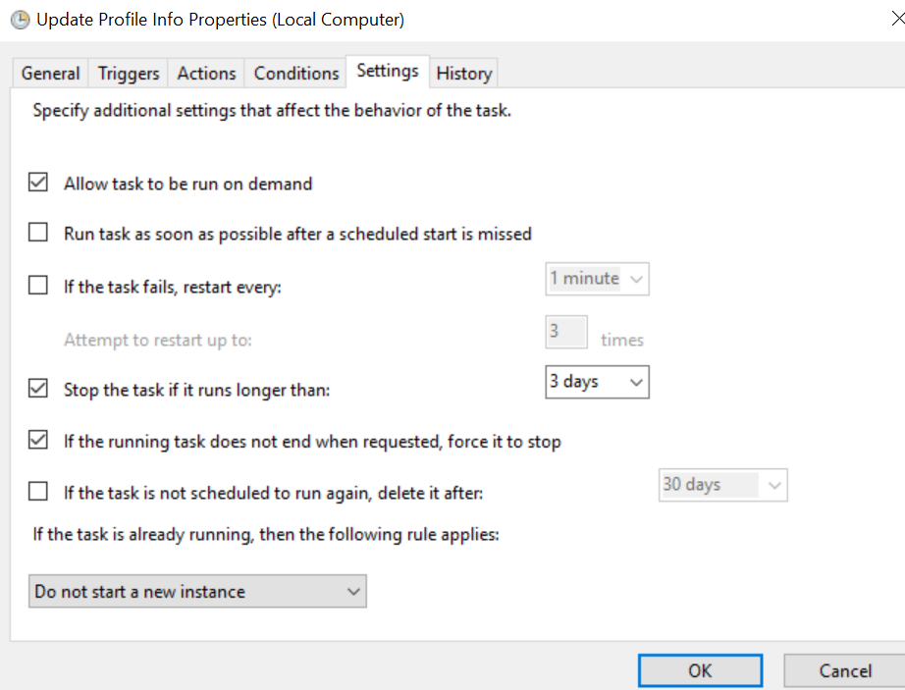

* + 1. History:

